KUGOO M4
User’s Manual
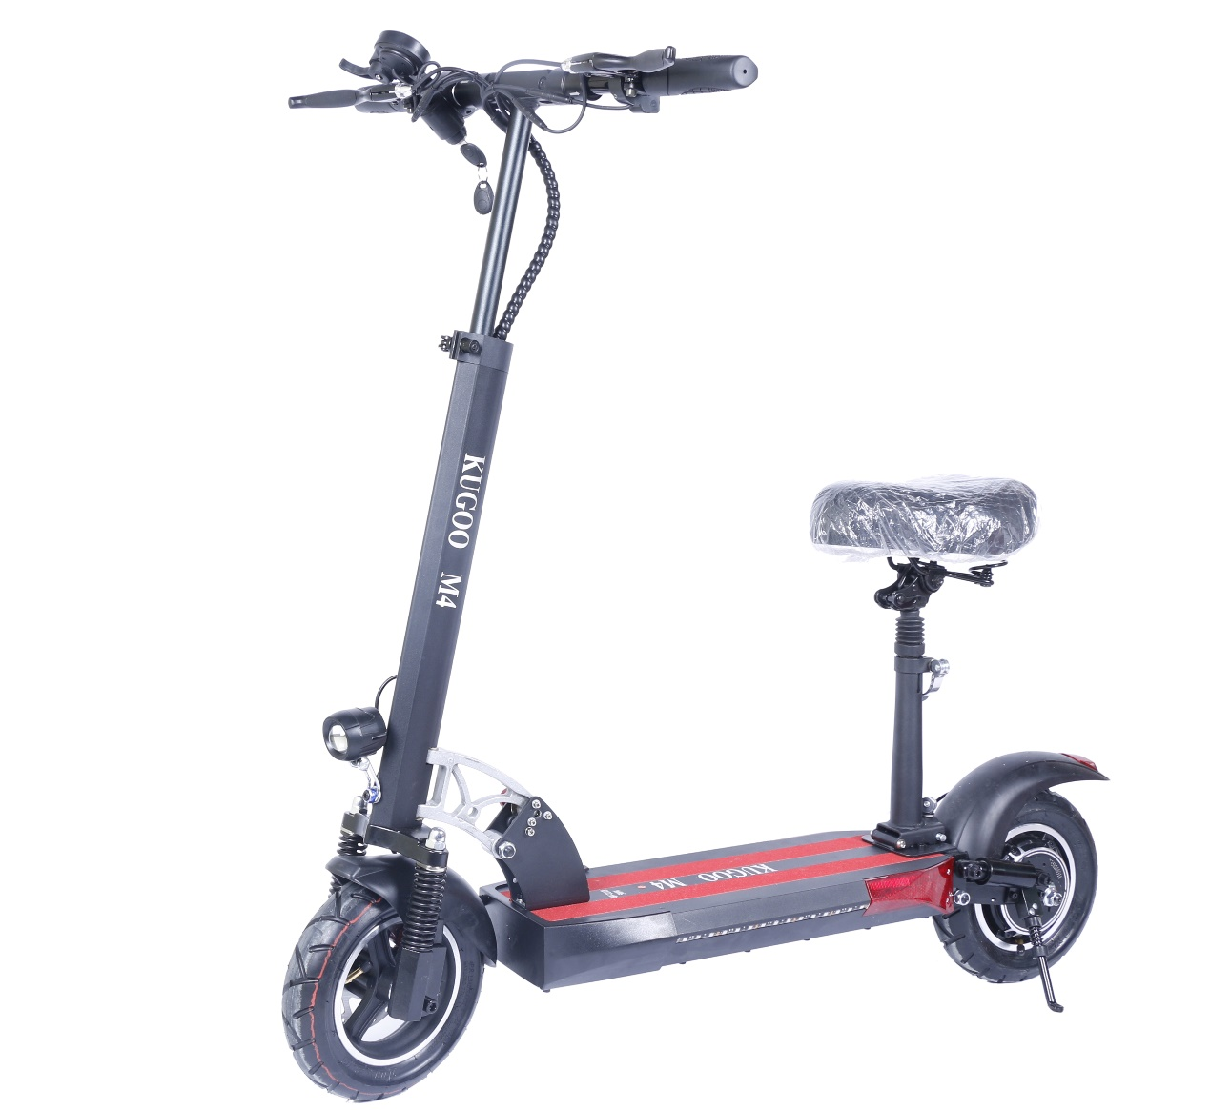
- Disclaimer
Under no circumstances, including but not limited to negligence, shall our distributor be liable for any special or consequential damages that result from the inability to use the materials in this manual, even if we have been advised of the possibility of such damages.
Applicable law may not allow the limitation or exclusion of liability or incidental or consequential damages, so the above limitation or exclusion may not apply to you.

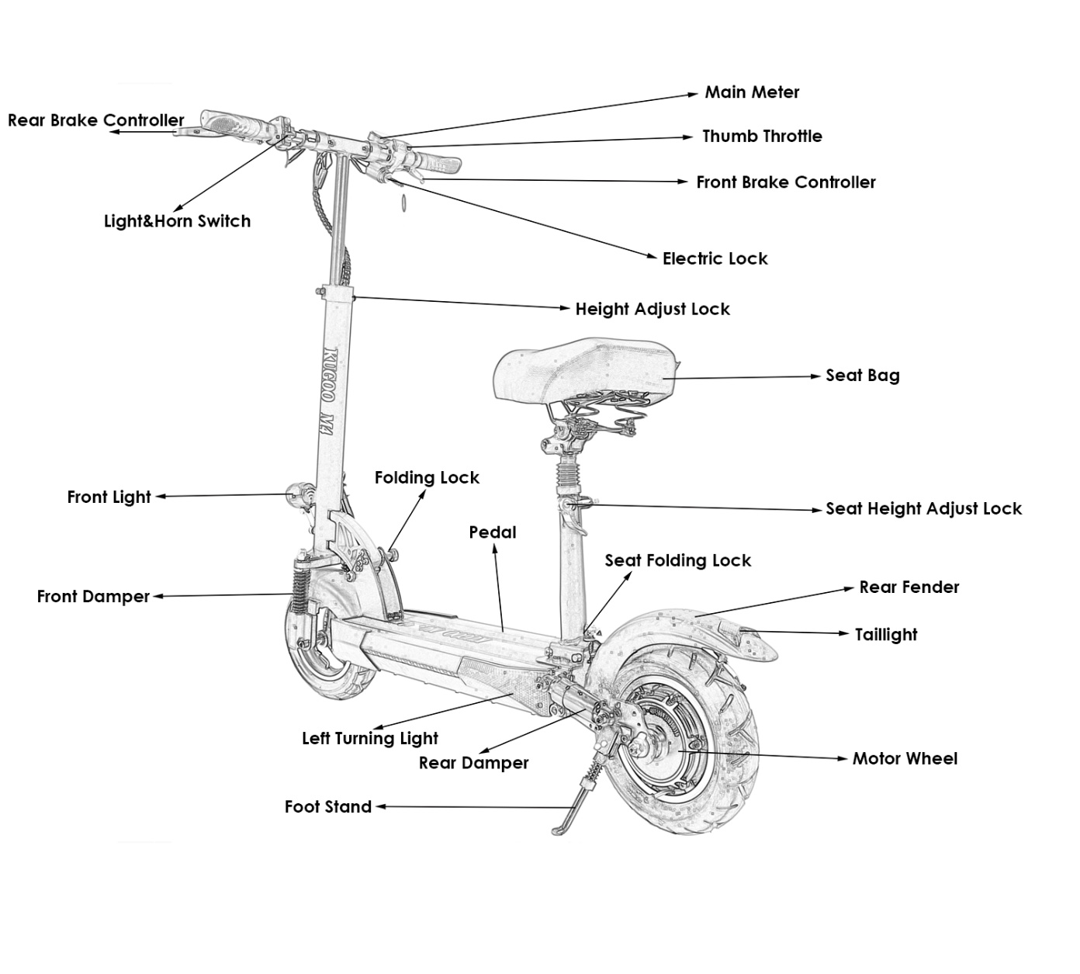
- Main Parts of the Scooter

- Folding the Scooter
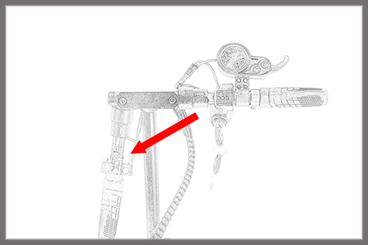
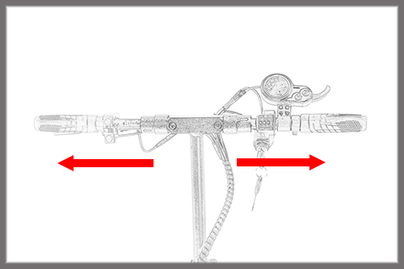

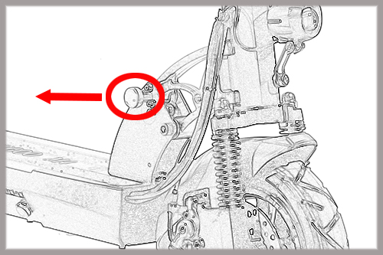
1/ Lock out the Handlebar
2/ Folding the Handlebar
3/ Take out the Folding Lock and
Folding the Scooter

- Charging the Scooter
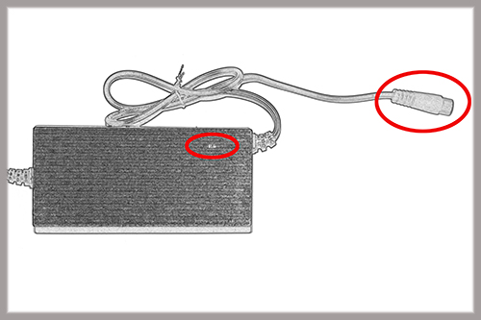
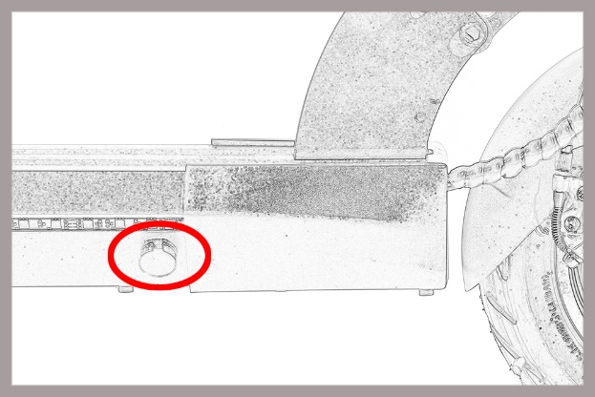
1/ Take out the Charger Port Cap 2/ Connect the Plug
3/ Red light means charging; Green light means charge-full or disconnected.

- How to Ride
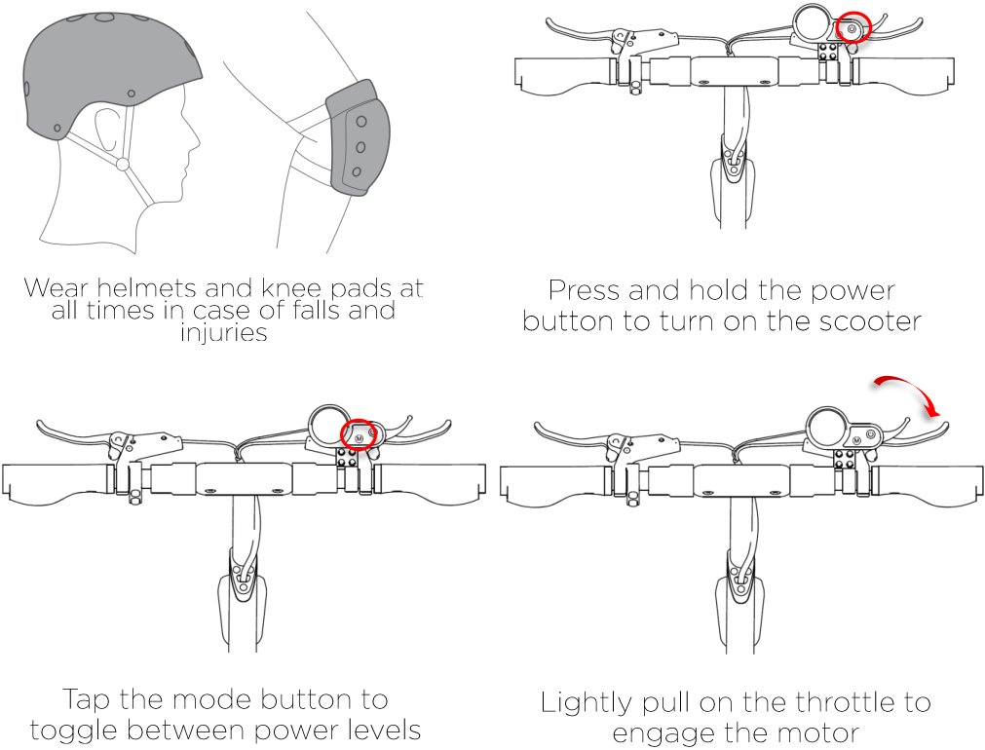

- Ride Safety
- Ensure all parts are tightly fitted and secure before you ride;
- Ensure a secure speed when the scooter driving on bumpy uneven surfaces;
- Don’t accelerate when travelling downhill;
- Don’t use the accelerator when pushing the scooter;
- Don't hang anything on the handlebar of the scooter;
- Don’t ride in a deeper puddles;
- Don’t ride with anyone on the scooter even kids;
- Don’t put your feet on rear dampers or fenders.

- Meter Button and Function
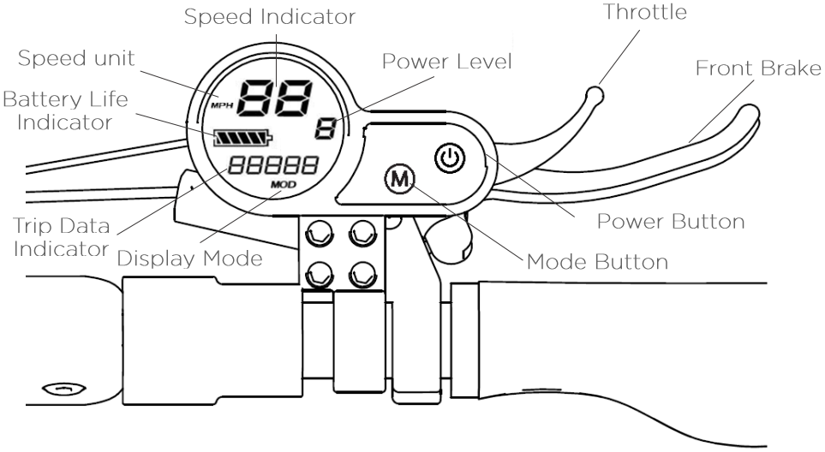

- Main Mode Selection
- Press and hold the power button 2-3 seconds to switch on the scooter
- Tap the MODE button to toggle between the 3 levels gears (1＜2＜3)
- Tap the power button to display and switch the screen.

ODO | Total Mileage
TRIP | Current Trip Mileage
VOLT | Battery Voltage in Time
CURRENT | Output Current in Time
ERROR | Error Data
TIME | Time Elapsed
English acronyms on the screen:

- Using the Power Lock
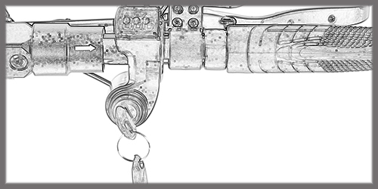
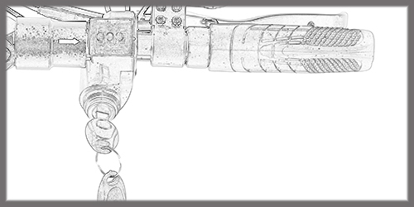

Turning Left to turn the power off Turning Right to turn the power on

- Headlights and Horn
The scooter is equipped with a headlight and a horn which can easily be activated from the dashboard

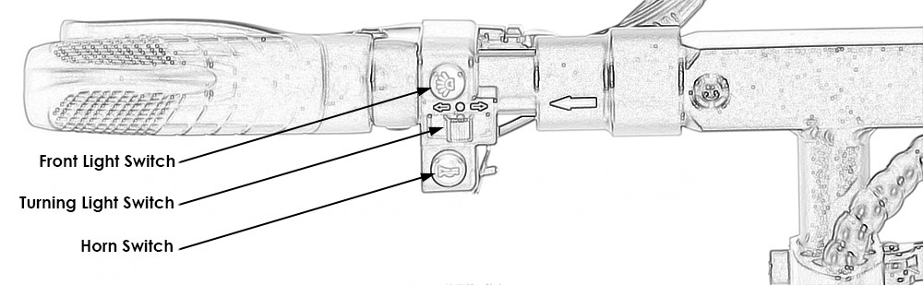

- Safety Reminder
- This electric scooter is a leisure device. But once they’re in a public area, they’ll be vehicles, subjecting to any risks faced by vehicles. For your safety, please follow instructions in the manual.
- Make sure you follow and are aware of traffic laws, regulations or restrictions set forth by your local government and regulatory agencies.
- Check the scooter before every use. When you note loosen parts, low battery alerts, flat tires, excessive wear, strange sounds, malfunctions and other abnormal conditions, stop riding immediately.
- Others may also pose a risk to your safety by careless or inappropriate driving. Make sure to be aware of your surroundings and never ride under the influence of drugs or alcohol.
- Respect pedestrians’ right of way try not to startle them and use caution when approaching them from behind.
- The faster you ride the longer your braking time. On smooth surfaces the scooter may slip, lose balance and may result in a fall. Always maintain a safe distance between others and obstacles.
- Don’t lend the scooter to anyone who does not know how to use it safely, please take the time and responsibility to ensure he/she knows how to operate the vehicle and wears the safety gear.
- Please follow the safety instructions in the manual and any rules or regulation in your jurisdiction. We shall not be liable for any financial losses, physical injuries, accidents, legal disputes and other conflicts that arise from actions that violate user instruction.

- Daily Care and Maintenance
- Use a damp cloth to clean and remove stains from the scooter. If needed an abrasive material such as sandpaper can be used to lightly polish the scooter. Don’t use alcohol, kerosene or any other corrosive material to clean the scooter.
- When the scooter is not in use, keep it indoors in a dry and cool environment.
- Use original battery packs, use of other brands may result in damage or fire.
- Don’t touch the battery contacts, do not dismantle or puncture, ensure contacts are far away from metal objects to avoid a short-circuit.
- Store the battery at about 40%-60% charge ensure the battery is not left in an environment above 50℃ or below -20℃.

- Technical Table
ITEM | SPECIFICATION
Motor Power | 48V, 500W
Battery Packs | 48V 11Ah Lithium-ion  21A Limited Output  Internal Battery Management System
Controller | 42V to 54.6V Sine Wave, 21A Limited Output
Lights | Front LED Light, Rear Brake Light
Brake | Mechanical Disc Brake  Power Off Brake
Dampers | Dual Spring Dampers both Front and Rear
Wheels | 10” Pneumatic Tires
Charging Time | 6 Hours
Max. Speed: | 45 Km/h
Max. Loading: | 150 Kg
Max. Range: | 50 Km
Max. Climbing | Approx. 14%
Dimensions | Unfolded:115x116x41.5 cm  Folded:115x41.5x23.5 cm
Item Weight | 23.6 Kg

- Warranty
We guarantee each new scooter frame against defects in workmanship and materials for one year. All original components are also covered by warranty for a period of one year from the date of purchase, but half an year for the battery pack. This warranty is expressly limited to the replacement of a defective frame, or defective parts and is the sole remedy of the warranty. This warranty applies only to original owners and is not transferable. Claims under this warranty must be made directly to the place at which you purchased the scooter, and proof of purchase is required, this warranty does not cover normal wear and tear, improper assembly or follow-up maintenance, or installation of parts or accessories. The warranty does not apply to damage or failure due to accident, misuse, abuse, or neglect. Modification of the frame or components shall void this warranty.

- Caution
As with all mechanical components, kick scooters are subjected to wear and tear, as well as high stresses. Different materials and components may fatigue in different ways. If the design life of a component has been exceeded, it can suddenly fail, possibly causing injuries to the rider. Any form of crack, scratches or change of coloring can indicate that the life of the components has been reached and should be replaced.

The scooter must comply with your countries legal requirements when riding on public roads and in all conditions, including bad weather, nighttime, dusk or dawn. Many countries require specific safety devices. It is your responsibility to familiarize yourself with the laws of the country where you ride and to comply with all applicable laws including properly equipping yourself and the scooter as the law requires.

